**AuE-6600: Dynamic Performance of Vehicles**

**Homework #6**

**Author:** Tanmay Samak

**Problem 1-A**

**Approach:**

I defined the single-track vehicle model in state-space form:

$X= \left[\begin{matrix}β \\ \dot{ψ}\end{matrix}\right]= \left[\begin{matrix}β \\ r\end{matrix}\right]$ where, $A= \left[\begin{matrix}-\frac{C_{α_{R}}+C_{α_{F}}}{m*v} & \frac{\left(C_{α_{R}}*b\right)-\left(C_{α_{F}}*a\right)}{m*v^{2}}-1 \\ \frac{\left(C_{α_{R}}*b\right)-\left(C_{α_{F}}*a\right)}{I_{z}} & -\frac{\left(C_{α_{R}}*b^{2}\right)+\left(C_{α_{F}}*a^{2}\right)}{I_{z}*v}\end{matrix}\right]$ and $B= \left[\begin{matrix}\frac{C_{α_{F}}}{m*v} \\ \frac{C_{α_{F}}*a}{Iz}\end{matrix}\right]$

I used Euler-forward to update the states throughout the simulation:

$$X_{t+1}=X_{t}+{\dot{X}}_{t}*∆t$$

I then calculated the velocity components of the vehicle:

$$v_{x}= v*\cos\left(ψ+β\right)$$

$$v_{y}= v*sin(ψ+β)$$

Then, I again used Euler-forward to update the position based on the velocity components:

$${P_{x}}_{t+1}={P_{x}}_{t}+{v_{x}}_{t}*∆t$$

$${P_{y}}_{t+1}={P_{y}}_{t}+{v_{y}}_{t}*∆t$$

**Plots:**

I plot the CG position for all time instants, and the velocity vectors at each 1-second interval (the CG origin is the starting point of each arrow).

|  |  |
| --- | --- |
|  |  |
| Step Maneuver - Trajectory | Fishhook Maneuver - Trajectory |

**Inference:**

The step input causes the vehicle to go in a circular trajectory of constant radius, while the fishhook maneuver causes the vehicle to go in circular trajectory of decreasing radii.

**Problem 1-B**

**Approach:**

I first calculated the coefficients `a` and `b`, which govern relationship between cornering stiffness and normal load. For this, I solved the linear system of equations (since it was an over-defined system of equations, I used MATLAB’s linsolve function, which uses QR factorization with column pivoting to solve over-defined system of equations):

Ca = 0.4474

Cb = -2.8236e-05

Next, I calculated static load over each tire:

$$\left\{\begin{aligned}S_{fl} = 0.5*0.6*m*9.81 \\ S_{fr} = 0.5*0.6*m*9.81 \\ S_{rl} = 0.5*0.4*m*9.81 \\ S_{rr} = 0.5*0.4*m*9.81\end{aligned}\right.$$

In the simulation loop (Euler forward), I first calculated lateral acceleration, ${a_{y}}_{t} = v*(\dot{β_{t-1}}+\dot{ψ_{t}})$. Next, I calculated the load transfer on each tire:

$$\left\{\begin{aligned}{dW}_{f}= 0.6*\frac{m*{a_{y}}_{t}*h}{w} \\ {dW}_{r} = 0.4*\frac{m*{a_{y}}_{t}*h}{w}\end{aligned}\right.$$

$$\left\{\begin{aligned}{F_{z}}_{fl} = S_{fl} - {dW}_{f} \\ {F_{z}}_{fr} = S_{fr}+ {dW}_{f} \\ {F_{z}}_{rl} = S_{rl} - {dW}_{r} \\ {F_{z}}_{rr} = S_{rr}+ {dW}_{r}\end{aligned}\right.$$

Next, I calculated the cornering stiffness for each tire based on the normal load:

$$\left\{\begin{aligned}C_{α_{fl}} = (Ca*{F_{z}}_{fl} + Cb*{F_{z}}_{fl}^{2})*\left(180/π\right) \\ {C_{α}}_{fr} = \left(Ca*{F_{z}}_{fr} + Cb*{F_{z}}_{fr}^{2}\right)*\left(180/π\right) \\ {C_{α}}_{rl} = (Ca*{F_{z}}_{rl} + Cb*{F_{z}}_{rl}^{2})*\left(180/π\right) \\ {C_{α}}_{rr} = (Ca*{F_{z}}_{rr} + Cb*{F_{z}}_{rr}^{2})*\left(180/π\right)\end{aligned}\right.$$

$$\left\{\begin{aligned}\begin{aligned}C_{α_{f}} = C_{α_{fl}}+{C_{α}}_{fr} \\ {C_{α}}_{r} = {C_{α}}_{rl}+{C_{α}}_{rr}\end{aligned}\end{aligned}\right.$$

Finally, I simulated the state-space model of the vehicle using Euler forward and calculated velocity and position components (also using Euler forward), as described in Problem 1-A.

**Plots:**

Step Maneuver - Trajectory

|  |  |
| --- | --- |
| **Fishhook Maneuver without Load Transfer** | **Fishhook Maneuver with Load Transfer** |
|  |  |
|  |  |
| **Fishhook Maneuver without Load Transfer** | **Fishhook Maneuver with Load Transfer** |
|  |  |
|  |  |

**Inference:**

The linear tire model blows up after certain lateral acceleration (when accounting load transfer). Since the step maneuver is within the bounds, the entire simulation can be completed. However, for the fishhook maneuver, we can observe that even without load transfer, the maximum lateral acceleration is going close to 50 m/s2, which is too high a value for linear tire model. Hence, after considering load transfer, the values blow up (NaN) after simulating for certain portion of the maneuver.

**Problem 2-A**

**Approach:**

Since it was not clearly mentioned, I did this problem considering two cases (i) without load transfer and (ii) with load transfer.

In addition to solution for Problem 1-B, I calculate the slip angles for front and rear tires:

$$\left\{\begin{aligned}α_{f} =δ -\frac{\dot{ψ}*a}{v} -β \\ α_{r} =\frac{\dot{ψ}*b}{v} - β\end{aligned}\right.$$

Next, I calculate the lateral force on each tire using the nonlintire function:

$$\left\{\begin{aligned}{F_{y}}_{fl} = -nonlintire(α_{f}, {F_{z}}_{fl}, v) \\ {F_{y}}_{fr} = -nonlintire(α_{f}, {F_{z}}_{fr}, v) \\ {F_{y}}_{rl} = -nonlintire(α_{r}, {F_{z}}_{rl}, v) \\ {F_{y}}_{rr} = -nonlintire(α_{r}, {F_{z}}_{rr}, v)\end{aligned}\right.$$

$$\left\{\begin{aligned}\begin{aligned}{F_{y}}_{f} = {F_{y}}_{fl}+{F_{y}}_{fr} \\ {F_{y}}_{r} = {F_{y}}_{rl}+{F_{y}}_{rr}\end{aligned}\end{aligned}\right.$$

Next, I calculate the state derivative matrix:

$$\dot{X}=\left[\begin{matrix}\frac{{F_{y}}_{f}+{F_{y}}_{r}}{m*v}- \dot{ψ} \\ \frac{{F_{y}}_{f}*a-{F_{y}}_{r}*b}{Iz}\end{matrix}\right]$$

Finally, I simulated the state-space model of the vehicle using Euler forward and calculated velocity and position components (also using Euler forward), as described in Problem 1-A.

**Plots:**

|  |  |  |
| --- | --- | --- |
| Step Maneuver without Load Transfer: | | |
|  |  |  |
| Trajectory | Vehicle Slip Angle | Vehicle Angular Velocity |

|  |  |  |
| --- | --- | --- |
| Step Maneuver with Load Transfer: | | |
|  |  |  |
| Trajectory | Vehicle Slip Angle | Vehicle Angular Velocity |

|  |  |  |
| --- | --- | --- |
| Fishhook Maneuver without Load Transfer: | | |
|  |  |  |
| Trajectory | Vehicle Slip Angle | Vehicle Angular Velocity |

|  |  |  |
| --- | --- | --- |
| Fishhook Maneuver with Load Transfer: | | |
|  |  |  |
| Trajectory | Vehicle Slip Angle | Vehicle Angular Velocity |

**Inference:**

The non-linear model captures the tire dynamics better than the linear model (especially at higher lateral acceleration values). We can observe that the radius of the curves has increased significantly, since the vehicle was sliding outwards at high lateral acceleration values (even more so with load transfer).

**Problem 2-B-(i)**

**Approach:**

I followed most of the approach as described in Problem 2-A (without load transfer). I recorded the lateral acceleration values along with steering commands and plotted them. Next, I fit a line to the linear region of the plot and calculate its slope.

$$UG = polyder\left(UG_{polyfit}\right)$$

However, for the fishhook maneuver (where radius is changing), we need to subtract the slope of neutral-steer gradient:

$$UG = polyder\left(UG_{polyfit}\right)-\frac{l}{v^{2}}$$

**Plots:**

Step Maneuver without Load Transfer:

UG for step maneuver with non-linear tire model, without load transfer is 0.0000 rad-s^2/m

Fishhook Maneuver without Load Transfer:

UG for fishhook maneuver with non-linear tire model, without load transfer is 0.0018 rad-s^2/m

**Inference:**

The vehicle is sublimit understeer, since UG is positive. However, calculating UG for step input does not seem truly possible. This is because UG can be calculated in either of the following cases:

* Vehicle is travelling at a constant radius (similar to step maneuver), but at varying speeds.
* Vehicle is travelling at a constant speed, but at gradually changing radius (similar to fishhook maneuver)

However, since in the case of step maneuver, we were given a constant velocity, the UG calculated may only reflect the UG at the given condition and may or may not be generalizable over the entire sublimit range.

**Problem 2-B-(ii)**

**Approach:**

I followed most of the approach as described in Problem 2-B-(i), but now only for fishhook maneuver with load transfer. I recorded the lateral acceleration values along with steering commands and plotted them. Next, I fit a line to the linear region of the plot and calculate its slope. However, since this is for the fishhook maneuver (where radius is changing), we need to subtract the slope of neutral-steer gradient:

**Plots:**

Fishhook Maneuver with Load Transfer:

UG for fishhook maneuver with non-linear tire model, with load transfer is 0.0025 rad-s^2/m

**Inference:**

The vehicle is sublimit understeer, since UG is positive.

For limit behavior I plotted the tire forces in the linear region of vs. plot:

From the above plot, it is evident that rear tire will saturate first (assuming identical tires in front and back). This means that at limit, the vehicle would exhibit oversteering behavior.

**Problem 2-B-(iii)**

**Approach:**

I followed most of the approach as described in Problem 2-B-(ii), but now with the new roll stiffness distribution. I recorded the lateral acceleration values along with steering commands and plotted them. Next, I fit a line to the linear region of the plot and calculate its slope. However, since this is for the fishhook maneuver (where radius is changing), we need to subtract the slope of neutral-steer gradient:

**Plots:**

Fishhook Maneuver with Load Transfer:

UG for fishhook maneuver with non-linear tire model, with load transfer is 0.0007 rad-s^2/m

**Inference:**

The vehicle is sublimit understeer, since UG is positive.

For limit behavior I plotted the tire forces in the linear region of vs. plot:

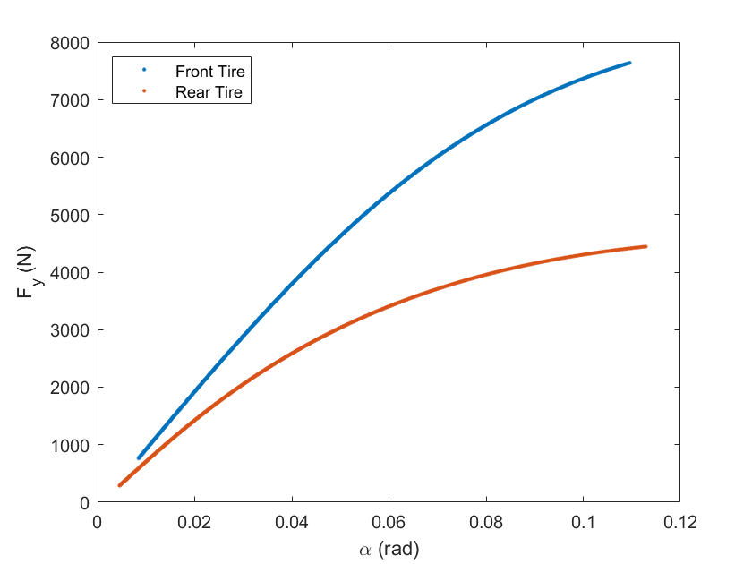

From the above plot, it is evident that rear tire will saturate first (assuming identical tires in front and back). This means that at limit, the vehicle would exhibit oversteering behavior.

Comparing this with plot from Problem 2-B-(ii), we can see that the difference in slopes in this case is more than the difference in slopes in case of Problem 2-B-(ii). This indicates that at limit behavior this vehicle would oversteer more than the vehicle in case of Problem 2-B-(ii).